**PL/SQL programming**

**Exercise 3: Stored Procedures**

--Create table accounts

CREATE TABLE accounts (

account_id NUMBER PRIMARY KEY,

account_holder VARCHAR2(100),

account_type VARCHAR2(20),

balance NUMBER(10,2)

);

INSERT INTO accounts (account_id,account_holder, account_type, balance) VALUES (123,'Alice', 'savings', 1000.00);

INSERT INTO accounts (account_id,account_holder, account_type, balance) VALUES (678,'Bob', 'current', 2000.00);

INSERT INTO accounts (account_id,account_holder, account_type, balance) VALUES (890,'Charlie', 'savings', 1500.00);

INSERT INTO accounts (account_id,account_holder, account_type, balance) VALUES (346,'Diana', 'savings', 2500.00);

SELECT * FROM accounts;

--Create table employees

CREATE TABLE employees (

employee_id NUMBER PRIMARY KEY,

name VARCHAR2(100),

department_id NUMBER,

salary NUMBER(10,2)

);

INSERT INTO employees (employee_id, name, department_id, salary) VALUES (101, 'Alice', 1, 50000.00);

INSERT INTO employees (employee_id, name, department_id, salary) VALUES (102, 'Bob', 2, 60000.00);

INSERT INTO employees (employee_id, name, department_id, salary) VALUES (103, 'Charlie', 1, 55000.00);

INSERT INTO employees (employee_id, name, department_id, salary) VALUES (104, 'Diana', 3, 70000.00);

SELECT * FROM employees;

--Scenario 1:

CREATE OR REPLACE PROCEDURE ProcessMonthlyInterest IS

BEGIN

UPDATE accounts

SET balance = balance * 1.01

WHERE account_type = 'savings';

END;

/

BEGIN

ProcessMonthlyInterest;

END;

/

SELECT * FROM accounts;

SELECT * FROM accounts WHERE account_type = 'savings';

--Scenario 2:

CREATE OR REPLACE PROCEDURE UpdateEmployeeBonus (

dept_id IN NUMBER,

bonus_percent IN NUMBER

) IS

BEGIN

UPDATE employees

SET salary = salary + (salary * bonus_percent / 100)

WHERE department_id = dept_id;

END;

/

BEGIN

UpdateEmployeeBonus(1, 10);

END;

/

SELECT * FROM employees;

SELECT * FROM employees WHERE department_id = 1;

--Scenario 3:

CREATE OR REPLACE PROCEDURE TransferFunds (

p_source_account_id IN NUMBER,

p_target_account_id IN NUMBER,

p_amount IN NUMBER

) AS

v_source_balance NUMBER;

BEGIN

-- Step 1: Get source balance

SELECT balance

INTO v_source_balance

FROM accounts

WHERE account_id = p_source_account_id;

DBMS_OUTPUT.PUT_LINE('Source account balance: ' || v_source_balance);

-- Step 2: Check sufficient balance

IF v_source_balance < p_amount THEN

DBMS_OUTPUT.PUT_LINE('Insufficient balance. Cannot transfer.');

RAISE_APPLICATION_ERROR(-20001, 'Insufficient balance in source account.');

END IF;

-- Step 3: Deduct from source account

UPDATE accounts

SET balance = balance - p_amount

WHERE account_id = p_source_account_id;

DBMS_OUTPUT.PUT_LINE('Deducted ' || p_amount || ' from account ' || p_source_account_id);

-- Step 4: Add to target account

UPDATE accounts

SET balance = balance + p_amount

WHERE account_id = p_target_account_id;

DBMS_OUTPUT.PUT_LINE('Added ' || p_amount || ' to account ' || p_target_account_id);

COMMIT;

DBMS_OUTPUT.PUT_LINE('Transfer completed successfully.');

EXCEPTION

WHEN NO_DATA_FOUND THEN

DBMS_OUTPUT.PUT_LINE('One or both account IDs do not exist.');

RAISE_APPLICATION_ERROR(-20002, 'Source or target account does not exist.');

WHEN OTHERS THEN

ROLLBACK;

DBMS_OUTPUT.PUT_LINE('Unexpected error: ' || SQLERRM);

RAISE;

END;

/

SET SERVEROUTPUT ON;

BEGIN

TransferFunds(123, 678, 200);

END;

/

SELECT account_id, account_holder, balance

FROM accounts

WHERE account_id IN (123, 678);

**OUTPUT:**

**Scenario 1:**

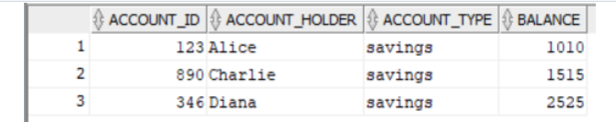

**Scenario 2:**

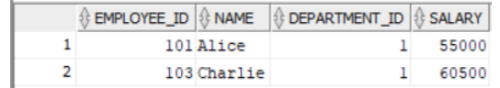

**Scenario 3:**

